**Make Inquiry Cartridge Setup Guide**

You need to follow below steps to install and configure the “Make Inquiry” Cartridge:-

* First you need to install the “Make Inquiry” cartridge from Appexchange.
* After that go to business manager and setup the cartridge path.
* Go to the custom object types in business manager and create new custom object named “Inquiry”.
* Create some custom fields in Inquiry object:- Customer Number, Customer Name, Email Address, Question, Product Id.
* Please take the reference the below screenshot. Please make sure to put exact letters that is provided in screeshot in ID for fields.

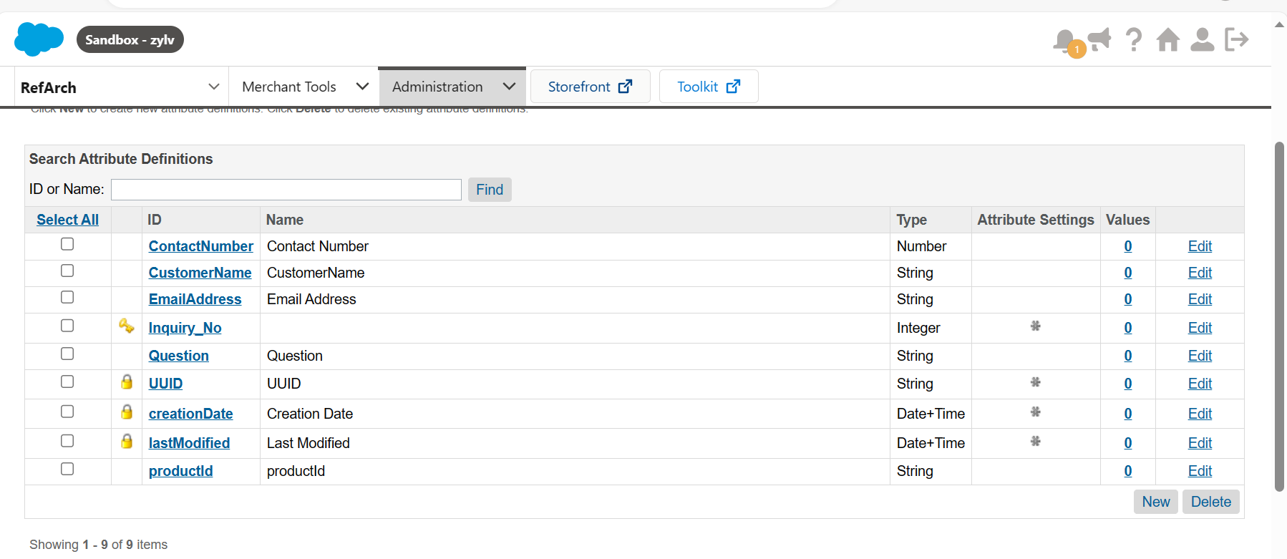

* Setup the email on which you want to receive product inquiries in “Customer Service Email”. Please ignore this step if you have already an email in Customer Service Email.  
    
    
  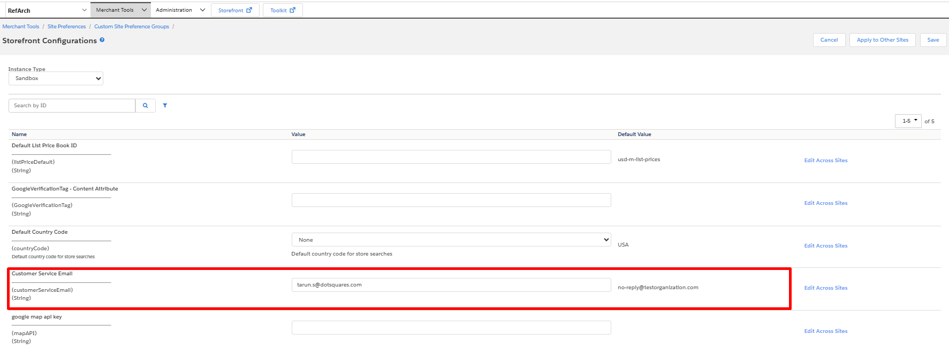
* After completing these steps customers can send the inquiries related to products.